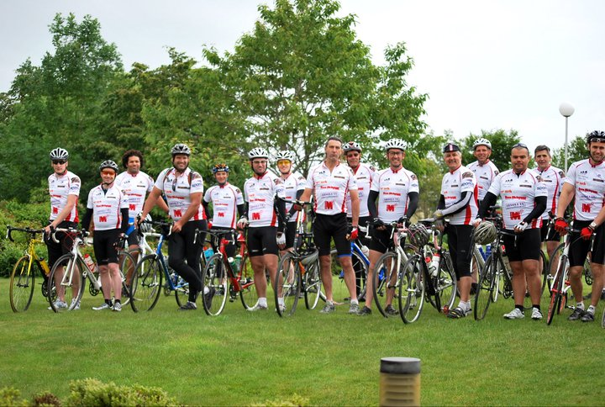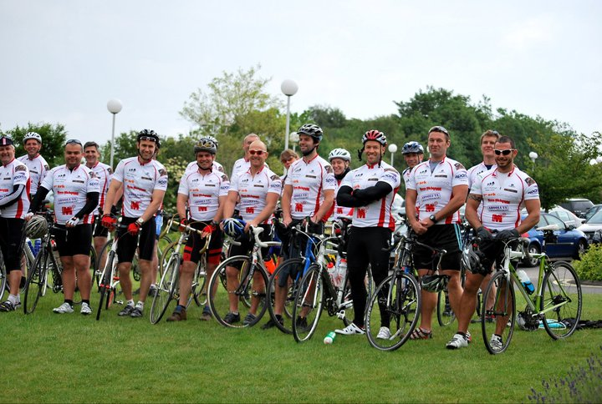

THANK YOU ALL VERY MUCH!!
Just to say a huge thank you for the sponsorship – with your help we raised a total of £3472.00!!
The whole event was a great challenge 536 miles, hills, wind, rain and loads of fun it’s certainly something we’ll remember for a very long time.
Now then what next.......????
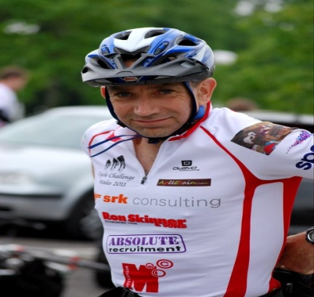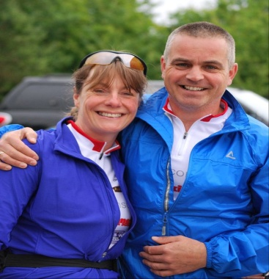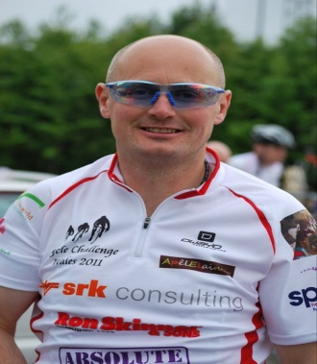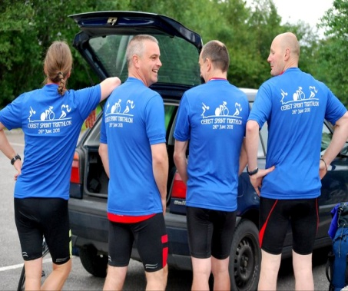
With our love, best wishes and sincere thanks – Garry, Andrew, Jeremy & Kim

